INVITATION TO TENDER (ITT) for Wildside Landscaping Project – Phase 1

In order to encourage wider use of the outdoor space around The Wildside Centre, Stratherrick & Foyers Community Trust are looking to make improvements to the area. This will be done in two phases, with Phase 1 focussing on the path surrounding the building. The focus of this Phase is:
- To upgrade the path around the Wildside building and extend it to the marquee entrance, making it accessible to all abilities and users (including wheelchairs).
- To incorporate ramps to fire exits into the lounge and lecture theatre and openings onto potential decked area at the rear of the land.
- Following consultation with the project team, our preferred option for path material is timber, as it is in keeping with the landscape and likely to be the most cost-effective.

We would like this Phase complete by 3rd December to enable us to plan towards the completion of Phase 2 in the Spring.

Your organisation, along with others, is invited to offer a tender for the provision of the above, to the specification outlined in the information on the following pages. Please read the instructions on the tendering procedures carefully. Failure to comply with them may invalidate your tender which must be returned by the date and time given below. A copy of your tender must be received by Laura Walker-Knowles, Administrator by emailing admin@sfctrust.org.uk no later than Friday 22nd October at 5pm. Late tenders will not be considered.

Please contact me if you have any questions about the tendering procedure. This document also contains details for providing you with further information or clarification of Stratherrick & Foyers Community Trust’s requirement.

Section 1 – Instructions and information on the tendering procedures
Please provide the following as part of your tender:
- Proposed design
- Outline of work required
- Details of suggested material
- Proposed cost (including material, labour, other???)
- Recommended timescale and availability

Section 2 – Specification of the Requirement
Please see page 3 of this document for a plan of the area where the work is required.

The existing path (marked on the attached diagram) is approx. 200m in length and currently covers uneven and undulating ground. This is to be upgraded to meet requirements for disabled access and extended to the entrance of the Marquee. In line with UK Government recommendations, the minimum width for wheelchair access is 1000mm.
Suggested work required:
- Area to be levelled and widened where necessary, to make it suitable for wheelchairs.
- Area to be lined with weed control fabric.
- Subframe to be built & laid
- Decking boards to be laid and treated.

Section 3 – Declaration and information to be provided by the Tenderer
Tendering Firm - Please provide your responses to the following questions.

1 | Full name of the supplier applying for this contract | Tick
2 | Registered company address
3 | Registered company number
4 | Registered VAT number - If not registered state ‘Not Registered’
5 | Company Status (Limited Company, LLP, Sole Trader etc)

Main contacts
1 | Main Contact | Tick
2 | Main Contact telephone / mobile / email
3 | Supervising Partner

Declaration
I declare that to the best of my knowledge the answers submitted to these questions are correct. I understand that the additional information will be used in the evaluation process to assess my organisation’s suitability and I am signing on behalf of

…………………………………………………………………………….. .
I understand that the Trust will reject my submission if I fail to answer these questions or if I provide false or misleading information.
Name

Signed

Date

Plan of Wildside Landscape:

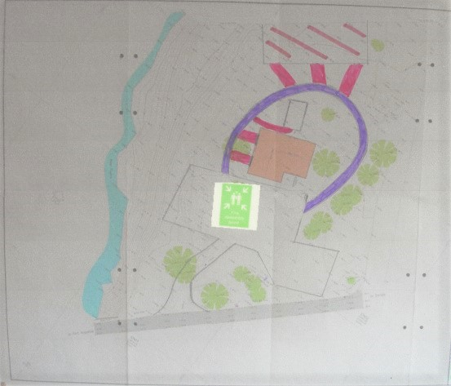

Key:
Wildside Building

Existing path that requires renovation

Proposed additional path areas

The hatched area to the North of the building and path is proposed for Phase 2 of the landscaping project.

Please note that this drawing is not to scale.

